
Year 3
2026-2027

Mrs Matthews  Class teacher | Mr Christensen  Class teacher | Miss Webb  TA | Miss Smalley  Phase HLTA | Miss Putt  PPA teacher | Mr Ball  PPA teacher
 |  | 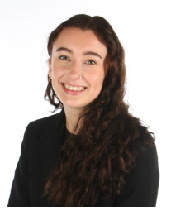 |  | 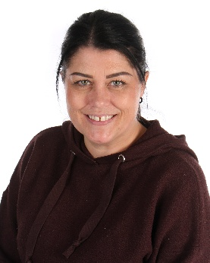 | 
Mr Wilkins  TA | Miss ?  TA | Mrs Conroy  TA and S+L support
 |  | 

